Title

Author Name Surname¹, Author Name Surname², Author Name Surname³
¹Affiliation Department, Institution, City, Country.

E-mail: xxxx@xxx.it

The abstract should be written in English and cannot exceed one page (fit in this frame). For the title use Character Type Arial 12; authors’ name 10 and affiliation 9pt. In the authors’ list the name of the presenting author should be underlined. Text should be full justified, 1.2 leading, Arial 10. Do not leave blank lines between paragraphs. References should be numbered consecutively and placed in the text as superscript Arabic numeral surrounded by square brackets.^{[1]}
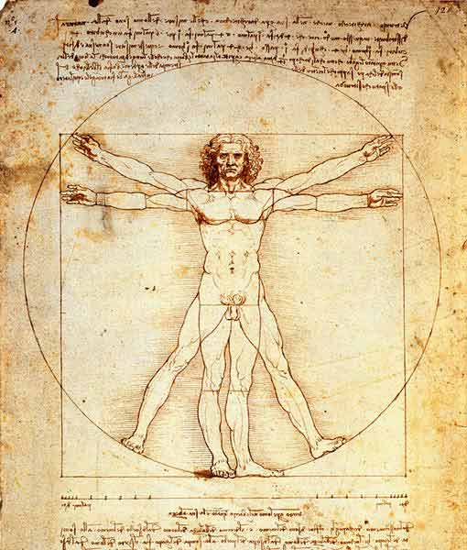
Use the “References” (Arial, 7,5pt single spaced, left aligned) syntax to write the bibliography.
Figure 1. Figure caption example
The abstract may contain table and or a figure. Figure will be printed in gray scale. Please, do not cite the figure in the text, but use captions to the figure. Figure should be centred without surrounding text. The captions should be centred with character size 7.

References
- A. Author, B. Author, Carbohydr. Polym. 2007, 90, 1-5.

